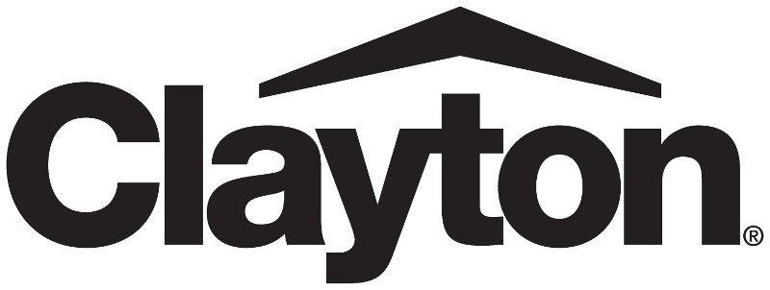

2027 Clayton Benefits Notices

Prescription Drug Coverage and Medicare
Women’s Health and Cancer Rights Act Notice
Newborns’ and Mothers’ Health Protection Act
Patient Protection Disclosure
HIPAA Special Enrollment Notice
Dependent Eligibility for Medical Coverage
Wellness Program Disclosure
Notice that Fixed Indemnity Insurance Is Not Group Health Coverage
Transparency in Health Coverage
Continuation Coverage Rights Under COBRA
Availability of Summary Health Information
Notice of Availability of Notice of Privacy Practices
Notice of Privacy Practices
Your Rights and Protections Against Surprise Medical Bills
Discrimination Is Against the Law
Foreign Language Assistance
New Health Insurance Marketplace Coverage Options and Your Health Coverage
Premium Assistance Under Medicaid and the Children’s Health Insurance Program
October 1, 2026

Important Notice from Clayton Homes, Inc. About Your Prescription Drug Coverage and Medicare
Please read this notice carefully and keep it where you can find it. This notice has information about your current prescription drug coverage with Clayton Homes, Inc. and about your options under Medicare’s prescription drug coverage. This information can help you decide whether or not you want to join a Medicare drug plan. If you are considering joining, you should compare your current coverage, including which drugs are covered at what cost, with the coverage and costs of the plans offering Medicare prescription drug coverage in your area.
Information about where you can get help to make decisions about your prescription drug coverage is at the end of this notice.
There are two important things you need to know about your current coverage and Medicare’s prescription drug coverage:
- Medicare prescription drug coverage became available in 2006 to everyone with Medicare. You can get this coverage if you join a Medicare Prescription Drug Plan or join a Medicare Advantage Plan (like an HMO or PPO) that offers prescription drug coverage. All Medicare drug plans provide at least a standard level of coverage set by Medicare. Some plans may also offer more coverage for a higher monthly premium.
- Clayton Homes, Inc. has determined that the prescription drug coverage offered through Express Scripts is, on average for all plan participants, expected to pay out as much as standard Medicare prescription drug coverage pays and is therefore considered Creditable Coverage. Because your existing coverage is Creditable Coverage, you can keep this coverage and not pay a higher premium (a penalty) if you later decide to join a Medicare drug plan.
When Can You Join A Medicare Drug Plan?
You can join a Medicare drug plan when you first become eligible for Medicare and each year thereafter from October 15th to December 7th.
However, if you lose your current creditable prescription drug coverage through no fault of your own, you will also be eligible for a two (2) month Special Enrollment Period (SEP) to join a Medicare drug plan.
What Happens to Your Current Coverage if You Decide to Join a Medicare Drug Plan?
If you decide to join a Medicare drug plan, your current Clayton Homes, Inc. coverage will not be affected.
In-Network Simple Plan
Preventive | 100% as required by ACA
Generic | $20 Copay 30-day/$50 Copay 90-day
Preferred Brand Name | $120 Copay 30-day/$300 Copay 90-day
Non-Preferred Brand Name & Specialty | $250 Copay 30-dayl/$625 Copay 90-day
Combined Medical & RX Out of Pocket Max | $6,000 single / $12,000 family
In-Network Simple Plan Plus
Preventive | 100% as required by ACA
Generic | $10 Copay 30-day/$25 Copay 90-day
Preferred Brand Name | $60 Copay 30-day/$150 Copay 90-day Mail
Non-Preferred Brand Name & Specialty | $150 Copay 30-day/$375 Copay 90-day
Combined Medical & RX Out of Pocket Max | $4,000 single / $8,000 family
Tier I In-Network Guided Choice
Preventive | 100% as required by ACA
Generic | $10 Copay 30-day/$25 Copay 90-day
Preferred Brand Name | $60 Copay 30-day/$150 Copay 90-day Mail
Non-Preferred Brand Name & Specialty | $150 Copay 30-day/$375 Copay 90-day
Combined Medical & RX Out of Pocket Max | $6000 single / $12,000 family

If you do decide to join a Medicare drug plan and drop your current Clayton Homes, Inc. coverage, be aware that you and your dependents may not be able to get this coverage back.
When Will You Pay A Higher Premium (Penalty) To Join A Medicare Drug Plan?
You should also know that if you drop or lose your current coverage with Clayton Homes, Inc. and don’t join a Medicare drug plan within 63 continuous days after your current coverage ends, you may pay a higher premium (a penalty) to join a Medicare drug plan later. If you go 63 continuous days or longer without creditable prescription drug coverage, your monthly premium may go up by at least 1% of the Medicare base beneficiary premium per month for every month that you did not have that coverage. For example, if you go nineteen months without creditable coverage, your premium may consistently be at least 19% higher than the Medicare base beneficiary premium. You may have to pay this higher premium (a penalty) as long as you have Medicare prescription drug coverage. In addition, you may have to wait until the following October to join.
For More Information About This Notice Or Your Current Prescription Drug Coverage:
Contact the Senior Benefits Manager, Corporate Human Resources, Clayton Homes, Inc., 5000 Clayton Road, Maryville, TN 37804; (865)380-3000 ext. 5221 for further information.
NOTE: You’ll get this notice each year. You will also get it before the next period you can join a Medicare drug plan, and if this coverage through Clayton Homes, Inc. changes. You also may request a copy of this notice at any time.
For More Information About Your Options Under Medicare Prescription Drug Coverage…
More detailed information about Medicare plans that offer prescription drug coverage is in the “Medicare & You” handbook. You’ll get a copy of the handbook in the mail every year from Medicare. You may also be contacted directly by Medicare drug plans.
For more information about Medicare prescription drug coverage:
  - Visit www.medicare.gov
  - Call your State Health Insurance Assistance Program (see the inside back cover of your copy of the “Medicare & You” handbook for their telephone number) for personalized help
• Call 1-800-MEDICARE (1-800-633-4227).
TTY users should call 1-877-486-2048
If you have limited income and resources, extra help paying for Medicare prescription drug coverage is available. For information about this extra help, visit Social Security on the web at www.socialsecurity.gov, or call them at 1-800-772-1213 (TTY 1-800-325-0778).
Remember: Keep this Creditable Coverage notice. If you decide to join one of the Medicare drug plans, you may be required to provide a copy of this notice when you join to show whether or not you have maintained creditable coverage and, therefore, whether or not you are required to pay a higher premium (a penalty).
PLEASE READ: THE FOLLOWING ARE IMPORTANT NOTICES FROM THE CLAYTON HOMES, INC. HEALTH AND WELFARE PLAN
Women’s Health and Cancer Rights Act Notice If you have had or are going to have a mastectomy, you may be entitled to certain benefits under the Women’s Health and Cancer Rights Act of 1998 (WHCRA). For individuals receiving mastectomy-related benefits, coverage will be provided in a manner determined in consultation with the attending physician and the patient, for: All stages of reconstruction of the breast on which the mastectomy was performed; Surgery and reconstruction of the other breast to produce a symmetrical appearance; Prostheses; and
- Treatment of physical complications of the mastectomy, including lymphedema.
These benefits will be provided subject to the same copays, deductibles and coinsurance applicable to other medical and surgical benefits provided under your health plan. Therefore, the following apply:
Simple In-Network: Inpatient Stay $1,500/day; Outpatient Procedure $850 (no deductibles or coinsurance); office co-pay $50; specialist co-pay $150
Simple Plus In-Network: Inpatient Stay $750/day; Outpatient Procedure $425 (no deductibles or coinsurance); office co-pay $30; specialist co-pay $70
Guided Choice Tier I In-Network: Inpatient Stay $0/day; Outpatient Procedure $0 (no deductibles or coinsurance); office co-pay $0; specialist co-pay $0
If you would like more information on WHCRA benefits, call the Senior Benefits Manager, Corporate Human Resources, Clayton Homes, Inc., 5000 Clayton Road, Maryville TN 37804, (865)380-3000, ext. 5221.
Newborns’ and Mothers’ Health Protection Act Group health plans and health insurance issuers generally may not, under federal law, restrict benefits for any hospital length of stay in connection with childbirth for the mother or newborn child to less than 48 hours following a vaginal delivery, or less than 96 hours following a caesarean section. However, federal law generally does not prohibit the mother’s or newborn’s attending provider, after consulting with the mother, from discharging the mother or her newborn earlier than 48 hours (or 96 hours as applicable). In any case, plans and issuers may not, under federal law, require that a provider obtain authorization from the plan or the insurance issuer for prescribing a length of stay not in excess of 48 hours (or 96 hours).
Patient Protection Disclosure
Cigna and Blue Cross generally allow the designation of a primary care provider. You have the right to designate any primary care provider who participates in one of these networks and who is available to accept you or your family members. For information on how to select a primary care provider, and for a list of the participating primary care providers, contact the plan administrator. For children, you may designate a pediatrician as the primary care provider.
You do not need prior authorization from Cigna, Blue Cross, or from any other person (including a primary care provider) in order to obtain access to obstetrical or gynecological care from a health care professional in our network who specializes in obstetrics or gynecology. The health care professional, however, may be required to comply with certain procedures, including obtaining prior authorization for certain services, following a pre-approved treatment plan, or procedures for making referrals. For a list of participating health care professionals who specialize in obstetrics or gynecology, contact the plan administrator.

HIPAA Special Enrollment Notice
If you are declining enrollment for yourself or your dependents (including your spouse) because of other health insurance or group health plan coverage, you may be able to enroll yourself or your dependents in this plan if you or your dependents lose eligibility for that other coverage (or if the employer stops contributing towards your or your dependents’ other coverage). However, you must request enrollment within 30 days after your or your dependents’ other coverage ends (or after the employer stops contributing toward the other coverage).
In addition, if you have a new dependent as a result of marriage, birth, adoption, or placement for adoption, you may be able to enroll yourself and your dependents. However, you must request enrollment within 30 days after the marriage, birth, adoption, or placement for adoption.
Special enrollment rights also may exist in the following circumstances:
- If you or your dependents experience a loss of eligibility for Medicaid or a state Children’s Health Insurance Program (CHIP) coverage and you request enrollment within 60 days after that coverage ends; or,
- If you or your dependents become eligible for a state premium assistance subsidy through Medicaid or a state CHIP with respect to coverage under this plan and you request enrollment within 60 days after the determination of eligibility for such assistance.
Note: The 60-day period for requesting enrollment applies only in these last two listed circumstances relating to Medicaid and state CHIP. As described above, a 30-day period applies to most special enrollments.
To request special enrollment or obtain more information, contact your plan administrator.

Dependent Eligibility for Medical Coverage Be sure each of your eligible dependents is enrolled. Your health plan provides medical coverage for your lawful spouse and children up to age 26 (disabled children may also be eligible upon proof of a disabling medical condition that prevents them from working). For additional information on eligible dependents refer to your summary plan description (SPD).
You will need to provide your dependents’ full legal name and Social Security number when you enroll them. Note: You must remove dependents from coverage when they are no longer eligible. The Company may audit benefit eligibility at any time. If you think your child qualifies for continued coverage due to a disabling medical condition, you must notify the Company using the Disabled Dependent Certification Form within 31 days after the child reaches age 26. The plan will automatically remove children who are no longer eligible due to age. Failure to provide this notice and the completed Disabled Dependent Certification Form will result in the child’s permanent loss of dependent eligibility.
Wellness Program Disclosure
Clayton is committed to helping you achieve your best health. When a wellness program is offered, rewards for participating in the wellness program are available to eligible employees. If you are eligible for a wellness program and you think you might be unable to meet a standard for a reward under the wellness program, you might qualify for an opportunity to earn the same reward by different means. Contact us by using the contact information shown at the end of this Wellness Program Disclosure if a reward or incentive is offered under a wellness program and we will work with you (and, if you wish, with your doctor) to find a wellness program with the same reward or incentive that is right for you in light of your health status.
The Clayton EAP includes tobacco cessation, flu and other vaccine clinics, and, in prior years, a health risk assessment (“HR Assessment”) (collectively, “EAP wellness features” or “the program”). The program is administered according to federal rules permitting employer-sponsored wellness programs that seek to improve employee health or prevent disease, including the Americans with Disabilities Act of 1990, the Genetic Information Nondiscrimination Act of 2008, and the Health Insurance Portability and Accountability Act (“HIPAA”), as applicable, among others. You will be notified if you are eligible for one of the programs offered through the EAP; if you have any questions as to whether you are eligible for a program, please contact the Clayton Senior Benefits Manager using the contact information at the end of this Wellness Program Disclosure. Eligibility is generally based on available resources in a particular location.
The flu and other vaccine clinics are voluntary and available to you as and when a clinic is held at your worksite. Flu vaccines are typically held in the fall before flu season begins. Other vaccine clinics may be offered as circumstances indicate. You will receive advance notice of each clinic at your worksite and the opportunity to sign up if you want to be vaccinated (signing up will ensure adequate vaccine is available during the clinic). You are not required to participate in a vaccine clinic.
All Team Members (and their spouses and dependents age 18 and older) are eligible for tobacco cessation benefits. If you use tobacco products you may participate in the Quit-for-Life program. You will have a quit coach, nicotine replacement gum or patches, referral to a physician for prescription drugs as needed, and repeat enrollment if the program does not result in tobacco cessation for you. You are not required to participate in the tobacco cessation program and it will not affect your health coverage if you decline to participate.
If an HR Assessment is offered and you choose to participate, you will be asked to complete the HR Assessment form containing a series of questions about your health-related activities and behaviors and whether you have or had certain medical conditions (e.g., cancer, diabetes, or heart disease). You will also be asked to complete a biometric screening, which will include a blood test for lipid and glucose testing and the A1C diabetes test (also known as the hemoglobin A1C or Hb1c test), and provide weight, height and blood pressure. You are not required to complete the HR Assessment or to participate in the blood test or other medical examinations. If an incentive is offered in connection with an assessment or testing, Team Members who are unable to participate in the HR Assessment or the blood test may be entitled to a reasonable accommodation or an alternative standard rather than completing the HR Assessment or the testing.
Some divisions may offer incentives to Team Members who participate in health-related activities or achieve certain health outcomes. Voluntary insurance policies, such as the VOYA policies, may pay an incentive for completing a recommended health exam. If you are unable to participate in any of the health-related activities or achieve any of the health outcomes required to earn an incentive (if a health outcome is required), you may be entitled to a reasonable accommodation or an alternative standard in order to earn the incentive. Contact Clayton’s Senior Benefits Manager using the contact information provided at the end of this Wellness Program Disclosure to see whether you are entitled to a reasonable accommodation or alternative standard in connection with any wellness benefit offered by Clayton.
The vaccine clinics are designed to prevent or mitigate critical virus-borne illnesses. The tobacco cessation program aims to improve your health by addressing tobacco addiction. The information from your HR Assessment and the results from your biometric screening will be used to provide you with information to help you understand your current health and potential risks, and may also be used to offer you services through the wellness program. You also are encouraged to share your HR Assessment or testing results or concerns with your own doctor, as well as any of the personal information developed through any of the wellness benefits offered under the Clayton wellness program.
Other wellness benefits may be offered through the Clayton Homes, Inc. Group Health Plan (“Health Plan”). If you enroll in the “Top Doctor” wellness initiative and use a “Top Doctor”, your copays will be funded through your Garner health reimbursement account in 2027 up to $1,500 for TM-only health coverage and up to $3,000 for Family health coverage. If you enroll in the Guided Choice Option, you may qualify for $0 cost-share for treatment that is Tier I Preferred Coverage. You may also qualify for the Health Plan’s Diabetes Reversal and Nutrition Therapy programs from Virta if you meet the requirements for those programs.
If you work for the Oakwood division, you may be eligible to participate in the Oakwood Bucks wellness initiative.
Protection Against Disclosure of Medical Information
We are required by law to maintain the privacy and security of your personally identifiable health information. Although the wellness program and Clayton may use aggregate information it collects to design a program based on identified health risks in the workplace, the Clayton wellness program will never disclose any of your personal information either publicly or to your supervisor, except as necessary to respond to a request from you for a reasonable accommodation needed to participate in the wellness program, or as expressly permitted by law. Medical information that personally identifies you that is provided in connection with the wellness program will not be provided to your supervisors or managers and may never be used to make decisions regarding your employment.
Your health information will not be sold, exchanged, transferred, or otherwise disclosed except to the extent permitted by law to carry out specific activities related to a wellness or health program, and you will not be asked or required to waive the confidentiality of your health information as a condition of participating in the wellness program or receiving an incentive. Clayton may use your health and wellness information to analyze cost measures for the Health Plan and other benefits available through the employer and determine how to structure those programs. Anyone who receives your information for purposes of providing you services as part of the wellness program or analyzing benefit costs and programs will abide by the same confidentiality requirements. The only individuals who will receive your personally identifiable health information are a registered nurse or doctor, other trained medical staff, or a health coach in order to provide you with services under the wellness program, or the business associates engaged to assist the Health Plan with health care costs. The medical providers who provide services through the EAP wellness features are subject to the same privacy and security standards as the Health Plan because they are covered entities under HIPAA, and the Health Plan’s business associates (including their subcontractors) are required to maintain the privacy and security of protected health information under HIPAA and the business associate agreement.
In addition, all medical information obtained through the wellness program will be confidentially maintained separate from your personnel records, and no information you provide as part of the wellness program will be used in making any employment decision. Appropriate precautions will be taken to avoid any data breach, and in the event a data breach occurs involving information you provide in connection with the wellness program, we will notify you without unreasonable delay.
You may not be discriminated against in employment because of the medical information you provide as part of participating in the wellness program, nor may you be subjected to retaliation if you choose not to participate.
If you have questions or concerns regarding this notice, or about protections against discrimination and retaliation, please contact Holly Brock, Senior Benefits Manager, 5000 Clayton Road, Maryville, TN 37804; Tel. 865.380.3000 ext. 5221; Fax 865.738.6165; Holly.Brock@ClaytonHomes.com.
If you are uncertain about your eligibility for any of the EAP wellness features or any other wellness benefit offered by Clayton, or whether you may qualify for a reasonable accommodation or an alternative standard, or to request a reasonable accommodation or an alternative standard, use the following contact information to ask for more information.
Contact Information: Holly Brock, Senior Benefits Manager, 5000 Clayton Road, Maryville, TN 37804; Tel. 865.380.3000 ext. 5221; Fax 865.738.6165; Holly.Brock@ClaytonHomes.com.
Fixed indemnity insurance is not group health coverage.
Clayton offers voluntary insurance policies through VOYA, including fixed indemnity insurance. If you purchase a fixed indemnity policy, it is designed to pay you a limited dollar amount if you're sick or hospitalized. You're still responsible for paying the cost of your care. Be aware of the following:
• The payment you get isn't based on the size of your medical bill.
• There might be a limit on how much this policy will pay each year.
• This policy isn't a substitute for comprehensive health insurance.
• Since this policy isn't health insurance, it doesn't have to include most Federal consumer protections that apply to health insurance.
If you are looking for comprehensive health insurance, you may purchase health insurance through Clayton’s group health plan, or your spouse’s plan, or you may visit HealthCare.gov or call 1-800-318-2596 (TTY: 1-855-889-4325) to find health coverage options. If you have a complaint about a VOYA policy, contact Holly Brock, Senior Benefits Manager, 5000 Clayton Road, Maryville, TN 37804; Tel. 865.380.3000 ext. 5221; Fax 865.738.6165; Holly.Brock@ClaytonHomes.com or your State Department of Insurance (find their number on the National Association of Insurance Commissioners' website (naic.org) under "Insurance Departments).
Transparency in Health Coverage
Clayton’s Health Plan is a self-insured plan. If you have a question about the cost of healthcare treatment (items and services) under the Health Plan, you may request a cost estimate for the item or service from your assigned third-party administrator (Cigna or Blue Cross and Blue Shield of Alabama, based on your employment location, referred to as “your TPA”) through the Company website at https://careers.claytonhomes.com/benefits and at bit.ly/claytonbenefits by clicking on the link labeled “Transparency in Coverage”. You may use this link to request cost estimates for medical items and services. The estimate is based on machine readable files which contain negotiated service rates for in-network providers (doctors, hospitals, clinics, etc., which have agreed to provide medical items and services to the Health Plan at the negotiated rates) and the maximum amount the Health Plan has paid historically for a covered item or service (commonly referred to as the “allowed amount”) when the item or service is furnished by an out-of-network provider (doctors, hospitals, clinics, etc., which do not have a contract with the Health Plan to provide services at pre-negotiated rates). The link will generate the estimated cost to you of an item or service based on the cost-sharing (co-pays, coinsurance and/or deductibles) for your Health Plan coverage (Simple, Simple Plus or Guided Choice) and the negotiated rate for an in-network provider or the allowed amount for an out-of-network provider. If you have questions about this notice or how to use the Transparency in Coverage link, contact Holly Brock, Senior Benefits Manager, 5000 Clayton Road, Maryville, TN 37804; Tel. 865.380.3000 ext. 5221; Fax 865.738.6165; Holly.Brock@ClaytonHomes.com.
COBRA Continuation Coverage Rights
This notice applies to you because you are eligible for coverage (if you are a full-time employee working 30 or more hours a week) under one or more of the Company’s health benefit plans (medical, vision, dental, employee assistance, wellness, health FSA) (the Plan). This notice has important information about your right to COBRA continuation coverage, which is a temporary extension of coverage under the Plan. This notice explains COBRA continuation coverage, when it may become available to you and your family, and what you need to do to protect your right to get it. When you become eligible for COBRA, you may also become eligible for other coverage options that may cost less than COBRA continuation coverage.
The right to COBRA continuation coverage was created by a federal law, the Consolidated Omnibus Budget Reconciliation Act of 1985 (COBRA). COBRA continuation coverage can become available to you and other members of your family when group health coverage would otherwise end. For more information about your rights and obligations under the Plan and under federal law, you should review the Plan’s Summary Plan Description or contact the plan administrator.
You may have other options available to you when you lose group health coverage. For example, you may be eligible to buy an individual plan through the Health Insurance Marketplace. By enrolling in coverage through the Marketplace, you may qualify for lower costs on your monthly premiums and lower out-of-pocket costs. Additionally, you may qualify for a 30-day special enrollment period for another group health plan for which you are eligible (such as a spouse’s plan), even if that plan generally doesn’t accept late enrollees.
What is COBRA continuation coverage?
COBRA continuation coverage is a continuation of Plan coverage when it would otherwise end because of a life event. This is also called a “qualifying event.” Specific qualifying events are listed later in this notice. After a qualifying event, COBRA continuation coverage must be offered to each person who is a “qualified beneficiary.” You, your spouse, and your dependent children could become qualified beneficiaries if coverage under the Plan is lost because of the qualifying event. Under the Plan, qualified beneficiaries who elect COBRA continuation coverage must pay for COBRA continuation coverage.
If you’re an employee, you’ll become a qualified beneficiary if you lose your coverage under the Plan because of the following qualifying events:
  - Your hours of employment are reduced, or
  - Your employment ends for any reason other than your gross misconduct.
If you’re the spouse of an employee, you’ll become a qualified beneficiary if you lose your coverage under the Plan because of the following qualifying events:
  - Your spouse dies;
  - Your spouse’s hours of employment are reduced;
  - Your spouse’s employment ends for any reason other than his or her gross misconduct;
  - Your spouse becomes entitled to Medicare benefits (under Part A, Part B, or both); or
  - You become divorced or legally separated from your spouse (see below for your notice obligations regarding the divorce or separation in order to preserve COBRA continuation coverage rights).
Your dependent children will become qualified beneficiaries if they lose coverage under the Plan because of the following qualifying events:
  - The parent-employee dies;
  - The parent-employee’s hours of employment are reduced;
  - The parent-employee’s employment ends for any reason other than his or her gross misconduct;
  - The parent-employee becomes entitled to Medicare benefits (Part A, Part B, or both);
  - The parents become divorced or legally separated; or
  - The child stops being eligible for coverage under the Plan as a “dependent child” (see below for your notice obligations when the child has ceased to be eligible for any reason other than reaching age 26 in order to preserve COBRA continuation coverage rights).

When is COBRA continuation coverage available and what are my notice obligations?
The Plan will offer COBRA continuation coverage to qualified beneficiaries only after the plan administrator has been notified that a qualifying event has occurred. The employer must notify the plan administrator of the following qualifying events:
  - The end of employment or reduction of hours of employment;
  - Death of the employee;
  - The employee’s becoming entitled to Medicare benefits (under Part A, Part B, or both).
For all other qualifying events (divorce or legal separation of the employee and spouse or a dependent child’s losing eligibility for coverage as a dependent child), you must notify the plan administrator within 60 days after the qualifying event occurs. You must also notify OneSource Virtual of any changes in your contact information (address, telephone, email, etc.) on or after the date you terminate employment with Clayton or the date you or your dependent has any other qualifying event.
You must provide this notice to:
OneSource Virtual
Attn: COBRA & Direct Bill Dept.
9001 Cypress Waters Blvd.
Dallas TX 75019
Fax: 1-972-916-9973
The above address may also be used for any other correspondence related to your COBRA coverage. The customer service telephone number for OneSource Virtual is 1-866-634-9784 (note that all notices must be in writing; any telephone call to OneSource would be for informational purposes). Hours of operation are 7 AM to 7 PM CST. The Members Portal for OneSource Virtual is: https://cobra.onesourceadministrativesolutions.com.

How is COBRA continuation coverage provided?
Once the plan administrator receives notice that a qualifying event has occurred, COBRA continuation coverage will be offered to each of the qualified beneficiaries. Each qualified beneficiary will have an independent right to elect COBRA continuation coverage. Covered employees may elect COBRA continuation coverage on behalf of their spouses, and parents may elect COBRA continuation coverage on behalf of their children.
You will be notified of the cost for COBRA continuation coverage when you qualify for the coverage. Your COBRA premiums are payable to OneSource Virtual at the following address:
OneSource Virtual
P.O. Pox 2449
Omaha, NE 68103-2449
Premiums may also be paid online using the Members Portal for OneSource Virtual. Making a payment online with your checking or savings account, or with a credit or debit card will result in an additional $20.00 charge per payment. Access the Members Portal for OneSource Virtual at https://cobra.onesourceadministrativesolutions.com.
COBRA continuation coverage is a temporary continuation of coverage that generally lasts for 18 months due to employment termination or reduction of hours of work. Certain qualifying events, or a second qualifying event during the initial period of coverage, may permit a beneficiary to receive a maximum of 36 months of coverage.
There are also ways in which this 18-month period of COBRA continuation coverage can be extended:

Disability extension of 18-month period of COBRA continuation coverage
If you or anyone in your family covered under the Plan is determined by Social Security to be disabled and you notify the plan administrator in a timely fashion, you and your entire family may be entitled to get up to an additional 11 months of COBRA continuation coverage, for a maximum of 29 months. The disability would have to have started at some time before the 60th day of COBRA continuation coverage and must last at least until the end of the 18-month period of COBRA continuation coverage.

Second qualifying event extension of 18-month period of continuation coverage
If your family experiences another qualifying event during the 18 months of COBRA continuation coverage, the spouse and dependent children in your family can get up to 18 additional months of COBRA continuation coverage, for a maximum of 36 months, if the Plan is properly notified about the second qualifying event. This extension may be available to the spouse and any dependent children getting COBRA continuation coverage if the employee or former employee dies; becomes entitled to Medicare benefits (under Part A, Part B, or both); gets divorced or legally separated; or if the dependent child stops being eligible under the Plan as a dependent child.
This extension is only available if the second qualifying event would have caused the spouse or dependent child to lose coverage under the Plan had the first qualifying event not occurred.

Are there other coverage options besides COBRA Continuation Coverage?
Yes. Instead of enrolling in COBRA continuation coverage, there may be other coverage options for you and your family through the Health Insurance Marketplace, Medicaid, or other group health plan coverage options (such as a spouse’s plan) through what is called a “special enrollment period.” Some of these options may cost less than COBRA continuation coverage. You can learn more about many of these options at www.healthcare.gov.

Is my Guided Choice coverage option available for my COBRA Continuation Coverage?
Because the Guided Choice Option is not available in all worksites, it may not be available in all circumstances for your COBRA continuation coverage. If you are enrolled in the Guided Choice Option and you or a dependent experience a qualifying event, you may continue your enrollment in the Guided Choice Option as long as you continue to reside or seek treatment in the geographical region in which your Guided Choice designated worksite is located. If you move away from the geographical region in which your Guided Choice designated worksite is located, however, you may have to move to a Simple or Simple Plus coverage option for your continued COBRA coverage. Additionally, if you transfer employment within the Company, you or a covered dependent may not be able to continue participating in the Guided Choice Option if it is not offered in your new worksite location.

If you have questions
Questions concerning your Plan or your COBRA continuation coverage rights should be addressed to the contact or contacts identified below. For more information about your rights under the Employee Retirement Income Security Act (ERISA), including COBRA, the Patient Protection and Affordable Care Act, and other laws affecting group health plans, contact the nearest Regional or District Office of the U.S. Department of Labor’s Employee Benefits Security Administration (EBSA) in your area or visit www.dol.gov/ebsa. (Addresses and phone numbers of Regional and District EBSA Offices are available through EBSA’s website.) For more information about the Marketplace, visit www.HealthCare.gov.

Keep your Plan and the COBRA Administrator informed of address changes
To protect your family’s rights, let the plan administrator know about any changes in the addresses of family members. You should also keep a copy, for your records, of any notices you send to the plan administrator.
You must also notify OneSource Virtual of any changes in your contact information (address, telephone, email, etc.) occurring on or after the date your employment with Clayton ends or the date you or your dependent has any other qualifying event. Your plan contact information is: Senior Benefits Manager, Clayton Homes, Inc., 5000 Clayton Road, Maryville TN 37804, (865)380-3000, ext. 5221; Holly.Brock@ClaytonHomes.com.
Availability of Summary Health Information
As a team member, the health benefits available to you represent a significant component of your compensation package. They also provide important protection for you and your family in the case of illness or injury.
Your health plan offers a series of health coverage options. Choosing a health coverage option is an important decision. To help you make an informed choice, your plan makes available a Summary of Benefits and Coverage (“SBC”), which summarizes important information about any health coverage option in a standard format, to help you compare across options.
The SBC is available on the web at: bit.ly/claytonbenefits. Clayton plan documents are listed in chronological order following the current Benefits Guide. A paper copy is also available, free of charge, by calling (865)380-3000 ext. 7400 or emailing benefits@claytonhomes.com.
As specified under the Patient Protection and Affordable Care Act (PPACA), the SBC is a summary of material provisions of a health plan in a uniform format, accompanied by a glossary of health coverage and medical terms available at https://www.cms.gov/CCIIO/Resources/Files/Downloads/uniform-glossary-final.pdf. The SBC is intended to provide you with a means to compare the health coverage options available, including those in the open market and not offered through the Company.
The SBC is NOT a substitute for the health plan comparison charts or the summary plan description, which together provide additional information concerning the cost of coverage, covered services, excluded services, or limitations and requirements for coverage.

NOTICE OF AVAILABILITY OF NOTICE OF PRIVACY PRACTICES
CLAYTON HOMES, INC.
October 1, 2026
To: Participants in the Company’s HIPAA-covered Plans
From: Human Resources, Clayton Homes, Inc., 5000 Clayton Road, Maryville, TN 37804; 865-380-3000
Re: Availability of Notice of Privacy Practices
The Clayton Homes, Inc. Group Health and Welfare Benefits Plan (the “Plan”) maintains a Notice of Privacy Practices that provides information to individuals whose protected health information will be used or maintained by the Plan. If you would like a copy of the Plan's Notice of Privacy Practices, please contact the Privacy Official. The Privacy Official is the Senior Benefits Manager, Corporate Human Resources, Clayton Homes, Inc., 5000 Clayton Road, Maryville, TN 37804, phone number 865-380-3000 ext. 5221.
SUMMARY OF PRIVACY PRACTICES FOR CLAYTON HOMES, INC.
Summary of Privacy Practices. This Summary of Privacy Practices summarizes how medical information about you may be used and disclosed by the Clayton Homes, Inc. Group Health and Welfare Benefits Plan (the “Plan”) or others in the administration of your claims, and certain rights that you have. For a complete, detailed description of all privacy practices, as well as your legal rights, please refer to the accompanying Notice of Privacy Practices.
Our Pledge Regarding Medical Information. We are committed to protecting your personal health information. We are required by law to (1) make sure that any medical information that identifies you is kept private; (2) provide you with certain rights with respect to your medical information; (3) give you a notice of our legal duties and privacy practices; and (4) follow all privacy practices and procedures currently in effect.
How We May Use and Disclose Medical Information About You. We may use and disclose your personal health information without your permission to facilitate your medical treatment, for payment for any medical treatments, and for any other health care operation. We will disclose your medical information to employees of Clayton Homes, Inc. for plan administration functions; but those employees may not share your information for employment-related purposes. We may also use and disclose your personal health information without your permission, as allowed or required by law. Otherwise, we must obtain your written authorization for any other use and disclosure of your medical information. We cannot retaliate against you if you refuse to sign an authorization or revoke an authorization you had previously given.
Your Rights Regarding Your Medical Information. You have the right to inspect and copy your medical information, to request corrections of your medical information, and to obtain an accounting of certain disclosures of your medical information. You also have the right to request that additional restrictions or limitations be placed on the use or disclosure of your medical information, or that communications about your medical information be made in different ways or at different locations.
How to File Complaints. If you believe your privacy rights have been violated, you have the right to file a complaint with us or with the Office for Civil Rights. We will not retaliate against you for making a complaint.



NOTICE OF PRIVACY PRACTICES

THIS NOTICE OF PRIVACY PRACTICES DESCRIBES HOW MEDICAL INFORMATION ABOUT YOU MAY BE USED AND DISCLOSED AND HOW YOU CAN GET ACCESS TO THIS INFORMATION. PLEASE REVIEW IT CAREFULLY.
The Clayton Homes, Inc. Group Health and Welfare Plan, including its HIPAA-covered component benefit plans, including medical, dental, vision, wellness and employee assistance benefits (collectively referred to herein as the “Plan”), is sponsored by the Company. This Notice of Privacy Practices (the “Notice”) describes the legal obligations of the Plan and your legal rights regarding your protected health information held by the Plan under the Health Insurance Portability and Accountability Act of 1996 (“HIPAA”). Among other things, this Notice describes how your protected health information may be used or disclosed to carry out treatment, payment, or health care operations, or for any other purposes that are permitted or required by law.
We are required to provide this Notice of Privacy Practices to you pursuant to HIPAA.
The HIPAA Privacy Rule protects only certain medical information known as “protected health information.” Generally, protected health information is individually identifiable health information, including demographic information, collected from you or created or received by a health care provider, a health care clearinghouse, a health plan, or your employer on behalf of a group health plan that relates to:
(1) your past, present or future physical or mental health or condition;
(2) the provision of health care to you; or
(3) the past, present or future payment for the provision of health care to you.
If you have any questions about this Notice or about our privacy practices, please contact the Senior Benefits Manager, Corporate Human Resources, Clayton Homes, Inc., who is the Plan’s Privacy Official, at 5000 Clayton Road, Maryville, TN 37804, phone number 865-380-3000 ext. 5221.
Effective Date
The contents of this Notice were effective on September 23, 2013. This Notice is restated periodically as needed. The last update was in August 2025 to add the Federal Substance Abuse Rules.
Our Responsibilities
We are required by law to:
- maintain the privacy of your protected health information;
- provide you with certain rights with respect to your protected health information;
- provide you with a copy of this Notice of our legal duties and privacy practices with respect to your protected health information; and
- follow the terms of the Notice that is currently in effect.
We reserve the right to change the terms of this Notice and to make new provisions regarding your protected health information that we maintain, as allowed or required by law. If we make any material change to this Notice, we will provide you with a copy of our revised Notice of Privacy Practices by posting a revised copy on our website or by mail to your last-known address on file.
How We May Use and Disclose Your Protected Health Information
Under the law, we may use or disclose your protected health information under certain circumstances without your permission. The following categories describe the different ways that we may use and disclose your protected health information. For each category of uses or disclosures we will explain what we mean and present some examples. Not every use or disclosure in a category will be listed. However, all of the ways we are permitted to use and disclose information will fall within one of the categories.
For Treatment. We may use or disclose your protected health information to facilitate medical treatment or services by providers. We may disclose medical information about you to providers, including doctors, nurses, technicians, medical students, or other hospital personnel who are involved in taking care of you. For example, we might disclose information about your prior prescriptions to a pharmacist to determine if prior prescriptions contraindicate a pending prescription.
For Payment. We may use or disclose your protected health information to determine your eligibility for Plan benefits, to facilitate payment for the treatment and services you receive from health care providers, to determine benefit responsibility under the Plan, or to coordinate Plan coverage. For example, we may tell your health care provider about your medical history to determine whether a particular treatment is experimental, investigational, or medically necessary, or to determine whether the Plan will cover the treatment. We may also share your protected health information with a utilization review or precertification service provider. Likewise, we may share your protected health information with another entity to assist with the adjudication or subrogation of health claims or to another health plan to coordinate benefit payments.
For Health Care Operations. We may use and disclose your protected health information for other Plan operations. These uses and disclosures are necessary to run the Plan. For example, we may use medical information in connection with conducting quality assessment and improvement activities; underwriting, premium rating, and other activities relating to Plan coverage; submitting claims for stop-loss (or excess-loss) coverage; conducting or arranging for medical review, legal services, audit services, and fraud & abuse detection programs; business planning and development such as cost management; and business management and general Plan administrative activities. However, we are prohibited by law from using or disclosing protected health information that is genetic information for underwriting purposes.
To Business Associates. We may contract with individuals or entities known as Business Associates to perform various functions on our behalf or to provide certain types of services. In order to perform these functions or to provide these services, Business Associates will receive, create, maintain, use and/or disclose your protected health information, but only after they agree in writing with us to implement appropriate safeguards regarding your protected health information. For example, we may disclose your protected health information to a Business Associate to administer claims or to provide support services, such as utilization management, pharmacy benefit management or subrogation, but only after the Business Associate enters into a Business Associate contract with us.
As Required by Law. We will disclose your protected health information when required to do so by federal, state or local law. For example, we may disclose your protected health information when required by national security laws or public health disclosure laws.
To Avert a Serious Threat to Health or Safety. We may use and disclose your protected health information when necessary to prevent a serious threat to your health and safety, or the health and safety of the public or another person. Any disclosure, however, would only be to someone able to help prevent the threat. For example, we may disclose your protected health information in a proceeding regarding the licensure of a physician.
To Plan Sponsors. For the purpose of administering the Plan, we may disclose to certain employees of the Company protected health information. However, those employees will only use or disclose that information as necessary to perform plan administration functions or as otherwise required by HIPAA, unless you have authorized further disclosures. Your protected health information cannot be used for employment purposes without your specific authorization.
Special Situations
In addition to the above, the following categories describe other possible ways that we may use and disclose your protected health information. For each category of uses or disclosures, we will explain what we mean and present some examples. Not every use or disclosure in a category will be listed. However, all of the ways we are permitted to use and disclose information will fall within one of the categories.
Organ and Tissue Donation. If you are an organ donor, we may release your protected health information to organizations that handle organ procurement or organ, eye, or tissue transplantation or to an organ donation bank, as necessary to facilitate organ or tissue donation and transplantation.
Military and Veterans. If you are a member of the armed forces, we may release your protected health information as required by military command authorities. We may also release protected health information about foreign military personnel to the appropriate foreign military authority.
Workers' Compensation. We may release your protected health information for workers' compensation or similar programs. These programs provide benefits for work-related injuries or illness.
Public Health Risks. We may disclose your protected health information for public health actions. These actions generally include the following:
- to prevent or control disease, injury, or disability;
- to report births and deaths;
- to report child abuse or neglect;
- to report reactions to medications or problems with products;
- to notify people of recalls of products they may be using;
- to notify a person who may have been exposed to a disease or may be at risk for contracting or spreading a disease or condition;
- to notify the appropriate government authority if we believe that a patient has been the victim of abuse, neglect, or domestic violence. We will only make this disclosure if you agree, or when required or authorized by law.
Health Oversight Activities. We may disclose your protected health information to a health oversight agency for activities authorized by law. These oversight activities include, for example, audits, investigations, inspections, and licensure. These activities are necessary for the government to monitor the health care system, government programs, and compliance with civil rights laws.
Lawsuits and Disputes. If you are involved in a lawsuit or a dispute, we may disclose your protected health information in response to a court or administrative order. We may also disclose your protected health information in response to a subpoena, discovery request, or other lawful process by someone else involved in the dispute, but only if efforts have been made to tell you about the request or to obtain an order protecting the information requested.
Law Enforcement. We may disclose your protected health information if asked to do so by a law enforcement official—
- in response to a court order, subpoena, warrant, summons or similar process;
- to identify or locate a suspect, fugitive, material witness, or missing person;
- about the victim of a crime if, under certain limited circumstances, we are unable to obtain the victim's agreement;
- about a death that we believe may be the result of criminal conduct; and
- about criminal conduct.
Coroners, Medical Examiners and Funeral Directors. We may release protected health information to a coroner or medical examiner. This may be necessary, for example, to identify a deceased person or determine the cause of death. We may also release medical information about patients to funeral directors, as necessary to carry out their duties.
National Security and Intelligence Activities. We may release your protected health information to authorized federal officials for intelligence, counterintelligence, and other national security activities authorized by law.
Inmates. If you are an inmate of a correctional institution or are in the custody of a law enforcement official, we may disclose your protected health information to the correctional institution or law enforcement official if necessary (1) for the institution to provide you with health care; (2) to protect your health and safety or the health and safety of others; or (3) for the safety and security of the correctional institution.
Research. We may disclose your protected health information to researchers when:
(1) the individual identifiers have been removed; or
(2) when an institutional review board or privacy board has reviewed the research proposal and established protocols to ensure the privacy of the requested information, and approves the research.
Potential Impact of State Law. In some situations, the federal privacy laws do not preempt (or take precedence over) state privacy laws that give you greater privacy protections. As a result, the privacy laws of a particular state might impose a privacy standard under which we will be required to operate.
Federal Substance Abuse Rules. The Federal Substance Abuse Rules (1) govern the use and disclosure of substance abuse information and prohibit the Plan from further disclosing the protected health information unless further disclosure is expressly permitted by the written consent of the person to whom it pertains or as otherwise permitted by 42 C.F.R. Part 2; and (2) restrict use of substance use disorder treatment records to criminally investigate or prosecute any alcohol or drug abuse patient.
Required Disclosures
The following is a description of disclosures of your protected health information we are required to make.
Government Audits. We are required to disclose your protected health information to the Secretary of the United States Department of Health and Human Services when the Secretary is investigating or determining our compliance with the HIPAA privacy rule.
Disclosures to You. When you request, we are required to disclose to you the portion of your protected health information that contains medical records, billing records, and any other records used to make decisions regarding your health care benefits. We are also required, when requested, to provide you with an accounting of most disclosures of your protected health information if the disclosure was for reasons other than for payment, treatment, or health care operations, and if the protected health information was not disclosed pursuant to your individual authorization.
Other Disclosures
Personal Representatives. We will disclose your protected health information to individuals authorized by you, or to an individual designated as your personal representative, attorney-in-fact, etc., so long as you provide us with a written notice/authorization and any supporting documents (i.e., power of attorney). Note: Under the HIPAA privacy rule, we do not have to disclose information to a personal representative if we have a reasonable belief that:
(1) you have been, or may be, subjected to domestic violence, abuse or neglect by such person; or
(2) treating such person as your personal representative could endanger you; and
(3) in the exercise of professional judgment, it is not in your best interest to treat the person as your personal representative.
Spouses and Other Family Members. With only limited exceptions, we will send all mail to the employee. This includes mail relating to the employee's spouse and other family members who are covered under the Plan, and includes mail with information on the use of Plan benefits by the employee's spouse and other family members and information on the denial of any Plan benefits to the employee's spouse and other family members. If a person covered under the Plan has requested Restrictions or Confidential Communications (see below under “Your Rights”), and if we have agreed to the request, we will send mail as provided pursuant to the request for Restrictions or Confidential Communications.
Authorizations. Other uses or disclosures of your protected health information not described above will only be made with your written authorization. You may revoke written authorization at any time, so long as the revocation is in writing. Once we receive your written revocation, it will only be effective for future uses and disclosures. It will not be effective for any information that may have been used or disclosed in reliance upon the written authorization and prior to receiving your written revocation.
Below are some of the circumstances when we may use and disclose your medical information only with your authorization:
Psychotherapy Notes. With limited exceptions, your authorization is required for use or disclosure of psychotherapy notes, which are notes recorded by a mental health professional documenting the contents of a conversation during a private counseling session or a group, joint, or family counseling session and that are separated from the rest of your medical record.
Marketing. With limited exceptions, your authorization is required for use or disclosure of your medical information for marketing purposes.
Sale of Your Medical Information. Your authorization is required if we want to sell your medical information.
Your Rights
You have the following rights with respect to your protected health information:
Right to Inspect and Copy. You have the right to inspect and copy certain protected health information that may be used to make decisions about your health care benefits. To inspect and copy your protected health information, you must submit your request in writing to the Privacy Official. If you request a copy of the information, we may charge a reasonable fee for the costs of copying, mailing, or other supplies associated with your request.
We may deny your request to inspect and copy in certain very limited circumstances. If you are denied access to your medical information, you may request that the denial be reviewed by submitting a written request to the Privacy Official.
Right to Amend. If you feel that the protected health information we have about you is incorrect or incomplete, you may ask us to amend the information. You have the right to request an amendment for as long as the information is kept by or for the Plan.
To request an amendment, your request must be made in writing and submitted to the Privacy Official. In addition, you must provide a reason that supports your request.
We may deny your request for an amendment if it is not in writing or does not include a reason to support the request. In addition, we may deny your request if you ask us to amend information that:
- is not part of the medical information kept by or for the Plan;
- was not created by us, unless the person or entity that created the information is no longer available to make the amendment;
- is not part of the information that you would be permitted to inspect and copy; or
- is already accurate and complete.
If we deny your request, you have the right to file a statement of disagreement with us and any future disclosures of the disputed information will include your statement.
Right to an Accounting of Disclosures. You have the right to request an “accounting” of certain disclosures of your protected health information. The accounting will not include (1) disclosures for purposes of treatment, payment, or health care operations; (2) disclosures made to you; (3) disclosures made pursuant to your authorization; (4) disclosures made to friends or family in your presence or because of an emergency; (5) disclosures for national security purposes; and (6) disclosures incidental to otherwise permissible disclosures.
To request this list or accounting of disclosures, you must submit your request in writing to the Privacy Official. Your request must state a time period of no longer than six (6) years from the date of your request. Your request should indicate in what form you want the list (for example, paper or electronic). The first list you request within a 12-month period will be provided free of charge. For additional lists, we may charge you for the costs of providing the list. We will notify you of the cost involved and you may choose to withdraw or modify your request at that time before any costs are incurred.
You may also request and receive an accounting of disclosures of electronic health records made for treatment, payment, or health care operations during the prior three years for disclosures made on or after (1) January 1, 2014 for electronic health records acquired before January 1, 2009; or (2) January 1, 2011 for electronic health records acquired on or after January 1, 2009.
Right to Request Restrictions. You have the right to request a restriction or limitation on your protected health information that we use or disclose for treatment, payment, or health care operations. You also have the right to request a limit on your protected health information that we disclose to someone who is involved in your care or the payment for your care, such as a family member or friend. For example, you could ask that we not use or disclose information about a surgery that you had.
Except as provided in the next paragraph, we are not required to agree to your request. However, if we do agree to the request, we will honor the restriction until you revoke it or we notify you.
Effective April 14, 2003 (or such other date specified as the effective date under applicable law) and updated September 23, 2013, we will comply with any restriction request if (1) except as otherwise required by law, the disclosure is to the health plan for purposes of carrying out payment or health care operations (and is not for purposes of carrying out treatment); and (2) the protected health information pertains solely to a health care item or service for which the health care provider involved has been paid out-of-pocket in full.
To request restrictions, you must make your request in writing to the Privacy Official. In your request, you must tell us (1) what information you want to limit; (2) whether you want to limit our use, disclosure, or both; and (3) to whom you want the limits to apply—for example, disclosures to your spouse.
Right to Request Confidential Communications. You have the right to request that we communicate with you about medical matters in a certain way or at a certain location. For example, you can ask that we only contact you at work or by mail.
To request confidential communications, you must make your request in writing to the Privacy Official. We will not ask you the reason for your request. Your request must specify how or where you wish to be contacted. We will accommodate all reasonable requests if you clearly provide information that the disclosure of all or part of your protected information could endanger you.
Right to Be Notified of a Breach. You have the right to be notified in the event that we (or a Business Associate) discover a breach of unsecured protected health information.
Right to a Paper Copy of This Notice. You have the right to a paper copy of this notice. You may ask us to give you a copy of this notice at any time. Even if you have agreed to receive this notice electronically, you are still entitled to a paper copy of this notice.
To obtain a paper copy of this notice, free of charge, from the employer, please contact the Senior Benefits Manager, Corporate Human Resources, Clayton Homes, Inc., 5000 Clayton Road, Maryville, TN 37804, phone number 865-380-3000 ext. 5221. You may also obtain a paper copy of this notice at bit.ly/claytonbenefits.
Vaccination Information
We may request information about your vaccination status from you or from a covered entity if allowed by applicable law, including access allowed during a national public health emergency. Generally, when vaccination information is obtained, it will be obtained directly from you in an employment context rather than from another source. If you authorize us to obtain vaccination information about you from another source, we will utilize that source if feasible. Information you provide to us related to your vaccination status will be maintained in a confidential manner consistent with other employment information. Protected health information we obtain from a covered entity will be maintained in accordance with this Notice.
Complaints
If you believe that your privacy rights have been violated, you may file a complaint with the Plan or with the Office for Civil Rights of the United States Department of Health and Human Services. To file a complaint with the Plan, contact the Senior Benefits Manager, Corporate Human Resources of Clayton Homes, Inc., 5000 Clayton Road, Maryville, TN 37804, phone number 865-380-3000 ext. 5221. All complaints must be submitted in writing.
You will not be penalized, or in any other way retaliated against, for filing a complaint with the Office for Civil Rights or with us.
Privacy Official
The Privacy Official is the Senior Benefits Manager, Corporate Human Resources, Clayton Homes, Inc., 5000 Clayton Road, Maryville, TN 37804, phone number 865-380-3000 ext. 5221.

Your Rights and Protections Against Surprise Medical Bills
When you get emergency care or get treated by an out-of-network provider at an in-network hospital or ambulatory surgical center, you are protected from surprise billing or balance billing.
What is “balance billing” (sometimes called “surprise billing”)?
When you see a doctor or other health care provider, you may owe certain out-of-pocket costs, such as a copayment, coinsurance, and/or a deductible. You may have other costs or have to pay the entire bill if you see a provider or visit a health care facility that is not in your health plan’s network.
“Out-of-network” describes providers and facilities that have not signed a contract with your health plan. Out-of-network providers may be permitted to bill you for the difference between what your plan agreed to pay and the full amount charged for a service. This is called “balance billing.” This amount is likely more than in-network costs for the same service and might not count toward your annual out-of-pocket limit.
“Surprise billing” is an unexpected balance bill. This can happen when you cannot control who is involved in your care—like when you have an emergency or when you schedule a visit at an in-network facility but are unexpectedly treated by an out-of-network provider.
You are protected from balance billing for:
Emergency services
If you have an emergency medical condition and get emergency services from an out-of-network provider or facility, the most the provider or facility may bill you is your plan’s in-network cost-sharing amount (such as copayments and coinsurance). You cannot be balance billed for these emergency services. This includes services you may get after you are in stable condition, unless you give written consent and give up your protections not to be balanced billed for these post-stabilization services.
Certain services at an in-network hospital or ambulatory surgical center
When you get services from an in-network hospital or ambulatory surgical center, certain providers there may be out-of-network. In these cases, the most those providers may bill you is your plan’s in-network cost-sharing amount. This applies to emergency medicine, anesthesia, pathology, radiology, laboratory, neonatology, assistant surgeon, hospitalist, or intensivist services. These providers cannot balance bill you and may not ask you to give up your protections not to be balance billed.
If you get other services at these in-network facilities, out-of-network providers cannot balance bill you, unless you give written consent and give up your protections.
You are never required to give up your protections from balance billing. You also are not required to get care out-of-network. You can choose a provider or facility in your plan’s network.
When balance billing is not allowed, you also have the following protections:
- You are only responsible for paying your share of the cost (like the copayments, coinsurance, and deductibles that you would pay if the provider or facility were in-network). Your health plan will pay out-of-network providers and facilities directly.
- Your health plan generally must:
  - Cover emergency services without requiring you to get approval for services in advance (prior authorization).
  - Cover emergency services by out-of-network providers.
  - Base what you owe the provider or facility (cost-sharing) on what it would pay an in-network provider or facility and show that amount in your explanation of benefits (your EOB).
  - Count any amount you pay for emergency services or out-of-network services toward your deductible and out-of-pocket limit.
If you believe you have been wrongly billed, you may contact:
Medical:
Blue Cross and Blue Shield of Alabama – contact Customer Service at the phone number on the back of your Member ID Card or visit www.alabamablue.com.
Cigna – contact Customer Service at the phone number on the back of your Member ID Card or visit www.mycigna.com.
Prescription Drugs: Express Scripts (ESI) – contact ESI at 855-634-0226 or visit www.express-scripts.com.
For Questions and Answers on the No Surprises Act
Visit No Surprises Act | CMS for more information about your rights under federal law.
This notice is also available on your Clayton benefits website at bit.ly/claytonbenefits
Discrimination Is Against the Law
Clayton Homes, Inc., its affiliated companies, component benefits under the Clayton Homes, Inc. Group Health and Welfare Plan, and the Clayton Homes, Inc. 401(k) Retirement Plan (collectively, “Clayton”) comply with applicable Federal civil rights laws and do not discriminate on the basis of race, color, national origin, age, disability, or sex. Clayton does not exclude people or treat them differently because of race, color, national origin, age, disability, or sex.
Clayton provides free aids and services to people with disabilities to communicate effectively with us, such as qualified sign language interpreters and written information in other formats (large print, audio, accessible electronic formats, other formats), and free language services to people whose primary language is not English, such as qualified interpreters and information written in other languages. If you need these services, contact Clayton’s Civil Rights Coordinator, who is the Senior Benefits Manager, Corporate Human Resources for Clayton Homes, Inc.
If you believe that Clayton has failed to provide these services or discriminated in another way on the basis of race, color, national origin, age, disability, or sex, you can file a grievance with: Clayton Homes, Inc., Attn: Senior Benefits Manager, Corporate Human Resources, 5000 Clayton Road, Maryville, TN 37804. Tel. 865.380.3000 ext. 5221; Fax. 865.738.6165; Holly.Brock@ClaytonHomes.com.
You may file a grievance in person or by mail, fax, or email. If you need help filing a grievance, Holly Brock, Senior Benefits Manager, Corporate Human Resources, is available to help you using the above contact information.
You can also file a civil rights complaint with the U.S. Department of Health and Human Services, Office for Civil Rights, electronically through the Office for Civil Rights Complaint Portal, available at https://ocrportal.hhs.gov/ocr/portal/lobby.jsf, or by mail or phone at U.S. Department of Health and Human Services; 200 Independence Avenue, SW; Room 509F, HHH Building; Washington, D.C. 20201; 1-800-368-1019; 800-537-7697 (TDD). Complaint forms are available at http://www.hhs.gov/ocr/office/file/index.html.

FOREIGN LANGUAGE ASSISTANCE

 | New Health Insurance Marketplace Coverage Options and Your Health Coverage | Form Approved OMB No. 1210-0149 (expires 6-30-2023)
PART A: General Information
When key parts of the health care law take effect in 2014, there will be a new way to buy health insurance: the Health Insurance Marketplace. To assist you as you evaluate options for you and your family, this notice provides some basic information about the new Marketplace and employment-based health coverage offered by your employer.
What is the Health Insurance Marketplace?
The Marketplace is designed to help you find health insurance that meets your needs and fits your budget. The Marketplace offers "one-stop shopping" to find and compare private health insurance options. You may also be eligible for a new kind of tax credit that lowers your monthly premium right away. Open enrollment for health insurance coverage through the Marketplace begins in October 2013 for coverage starting as early as January 1, 2014.
Can I Save Money on my Health Insurance Premiums In the Marketplace?
You may qualify to save money and lower your monthly premium, but only if your employer does not offer coverage, or offers coverage that doesn't meet certain standards. The savings on your premium that you're eligible for depends on your household income.
Does Employer Health Coverage Affect Eligibility for Premium Savings through the Marketplace?
Yes. If you have an offer of health coverage from your employer that meets certain standards, you will not be eligible for a tax credit through the Marketplace and may wish to enroll in your employer's health plan. However, you may be eligible for a tax credit that lowers your monthly premium, or a reduction in certain cost-sharing if your employer does not offer coverage to you at all or does not offer coverage that meets certain standards. If the cost of a plan from your employer that would cover you (and not any other members of your family) is more than 9.5% of your household income for the year, or if the coverage your employer provides does not meet the "minimum value" standard set by the Affordable Care Act, you may be eligible for a tax credit.'
Note: If you purchase a health plan through the Marketplace instead of accepting health coverage offered by your employer, then you may lose the employer contribution (if any) to the employer-offered coverage. Also, this employer contribution –as well as your employee contribution to employer-offered coverage— is often excluded from income for Federal and State income tax purposes. Your payments for coverage through the Marketplace are made on an after-tax basis.
How Can I Get More Information?
For more information about your coverage offered by your employer, please check your summary plan description or
contact Holly Brock, at Holly.Brock@ClaytonHomes.com or (865)380-3000 ext. 5221.

The Marketplace can help you evaluate your coverage options, including your eligibility for coverage through the Marketplace and its cost. Please visit HealthCare.gov for more information, including an online application for health insurance coverage and contact information for a Health Insurance Marketplace in your area.
PART B: Information About Health Coverage Offered by Your Employer
This section contains information about any health coverage offered by your employer. If you decide to complete an application for coverage in the Marketplace, you will be asked to provide this information. This information is numbered to correspond to the Marketplace application.
3. Employer name 4. Employer Identification Number (EIN)
Clayton Homes, Inc. 62-1671360
5. Employer address 6. Employer phone number
5000 Clayton Road (865) 380-3000
7. City 8. State 9. ZIP code
Maryville TN 37804
- Who can we contact about employee health coverage at this job?
Holly Brock, Senior Benefits Manager

- Phone number (If different from above)  (865) 380-3000 ext. 5221 | - Email address  Holly.Brock@ClaytonHomes.com

Here is some basic information about health coverage offered by this employer:
- As your employer, we offer a health plan to:
All employees. Eligible employees are:
Some employees. Eligible employees are:
Full-time employees working at least 30 hours a week, other than Dept. of Corrections employees, seasonal employees, and interns (other than interns who are eligible under the Clayton ACA Measurement Period Policy).

With respect to dependents:
We do offer coverage. Eligible dependents are:
Your lawful spouse; your child (including adopted and foster children, and children for whom you are the legal
guardian) under age 26. Coverage is also available for certain adult children who are disabled.
We do not offer coverage.
If checked, this coverage meets the minimum value standard, and the cost of this coverage to you is intended to be affordable, based on employee wages.
** Even if your employer intends your coverage to be affordable, you may still be eligible for a premium discount through the Marketplace. The Marketplace will use your household income, along with other factors, to determine whether you may be eligible for a premium discount. If, for example, your wages vary from week to week (perhaps you are an hourly employee or you work on a commission basis), if you are newly employed mid—year, or if you have other income losses, you may still qualify for a premium discount.
If you decide to shop for coverage in the Marketplace, HealthCare.gov will guide you through the process. Here's the employer information you'll enter when you visit HealthCare.gov to find out if you can get a tax credit to lower your monthly premiums.

The information below corresponds to the Marketplace Employer Coverage Tool. Completing this section is optional for employers, but will help ensure employees understand their coverage choices.
13. Is the employee currently eligible for coverage offered by this employer, or will the employee be eligible in the next 3 months?
X Yes (Continue)
13a. If the employee is not eligible today, including as a result of a waiting or probationary period, when is the
employee eligible for coverage? 31st day of employment if working FT at least 30 hours a week (mm/dd/yyyy) (Continue)
0 No (STOP and return this form to employee)
14. Does the employer offer a health plan that meets the minimum value standard*?
X Yes (Go to question 15) No (STOP and return form to employee)
15. For the lowest-cost plan that meets the minimum value standard* offered only to the employee (don't include family plans): If the employer has wellness programs, provide the premium that the employee would pay if he/she received the maximum discount for any tobacco cessation programs, and didn't receive any other discounts based on wellness programs.
- How much would the employee have to pay in premiums for this plan? $23.81 in 2026
- How often? X Weekly Every 2 weeks Twice a month Monthly Quarterly Yearly
If the plan year will end soon and you know that the health plans offered will change, go to question 16. If you don't know, STOP and return form to employee.

16. What change will the employer make for the new plan year?
Employer won't offer health coverage
x Employer will start offering health coverage to employees or change the premium for the lowest-cost plan
available only to the employee that meets the minimum value standard.* (Premium should reflect the discount for wellness programs. See question 15.)
- How much would the employee have to pay in premiums for this plan? $24.76 for Guided Choice in 2027
- How often? X Weekly Every 2 weeks Twice a month Monthly Quarterly Yearly
* An employer—sponsored health plan meets the “minimum value standard" if the plan's share of the total allowed benefit costs covered by the plan is no less than 60 percent of such costs (Section 36B(c)(2)(C)(ii) of the Internal Revenue Code of 1986)

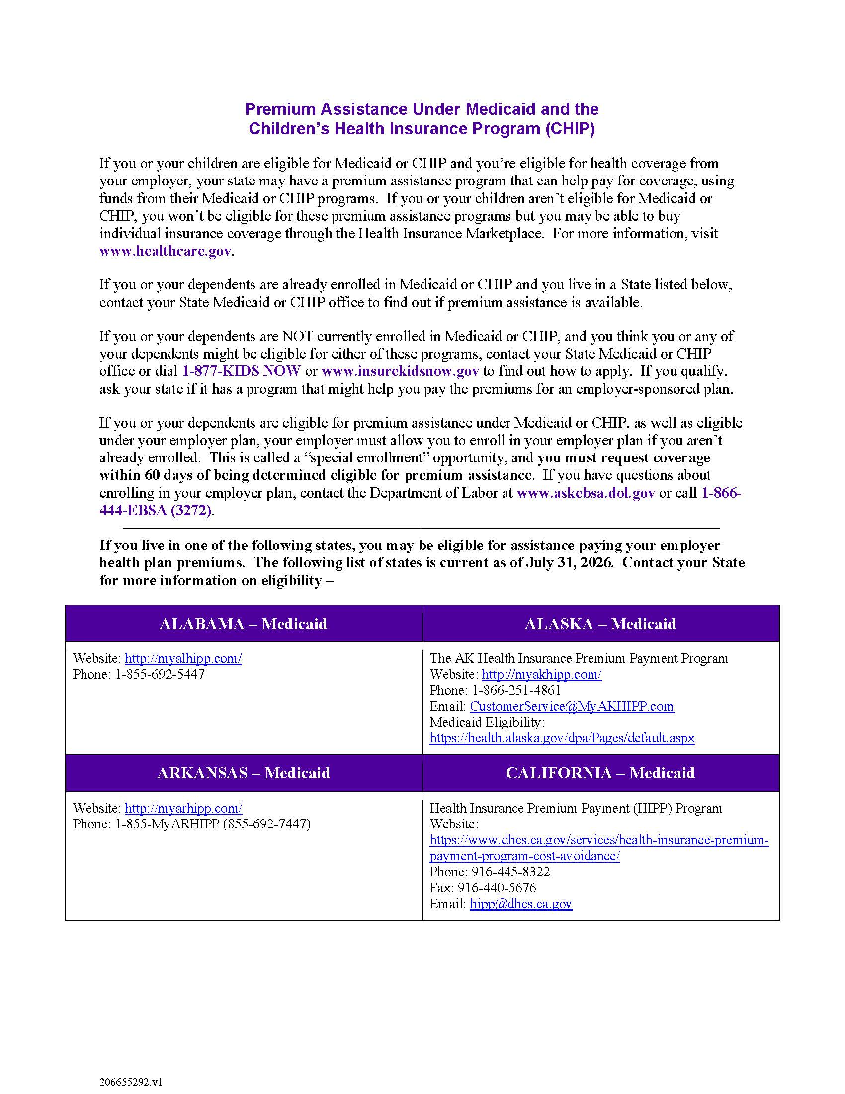
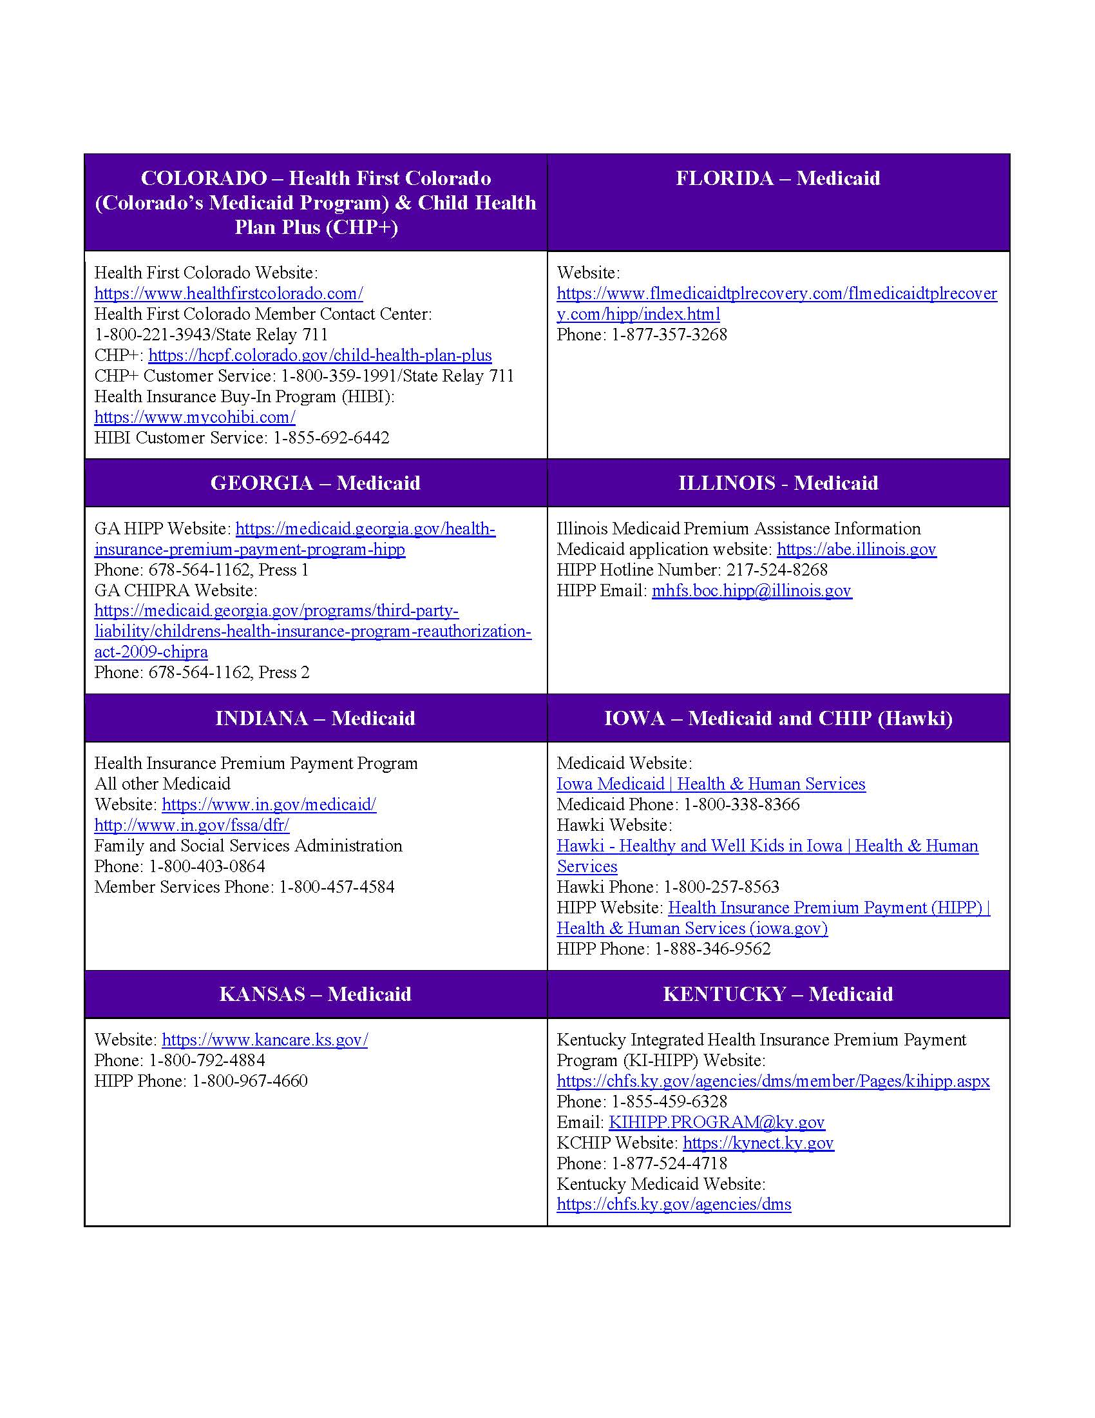
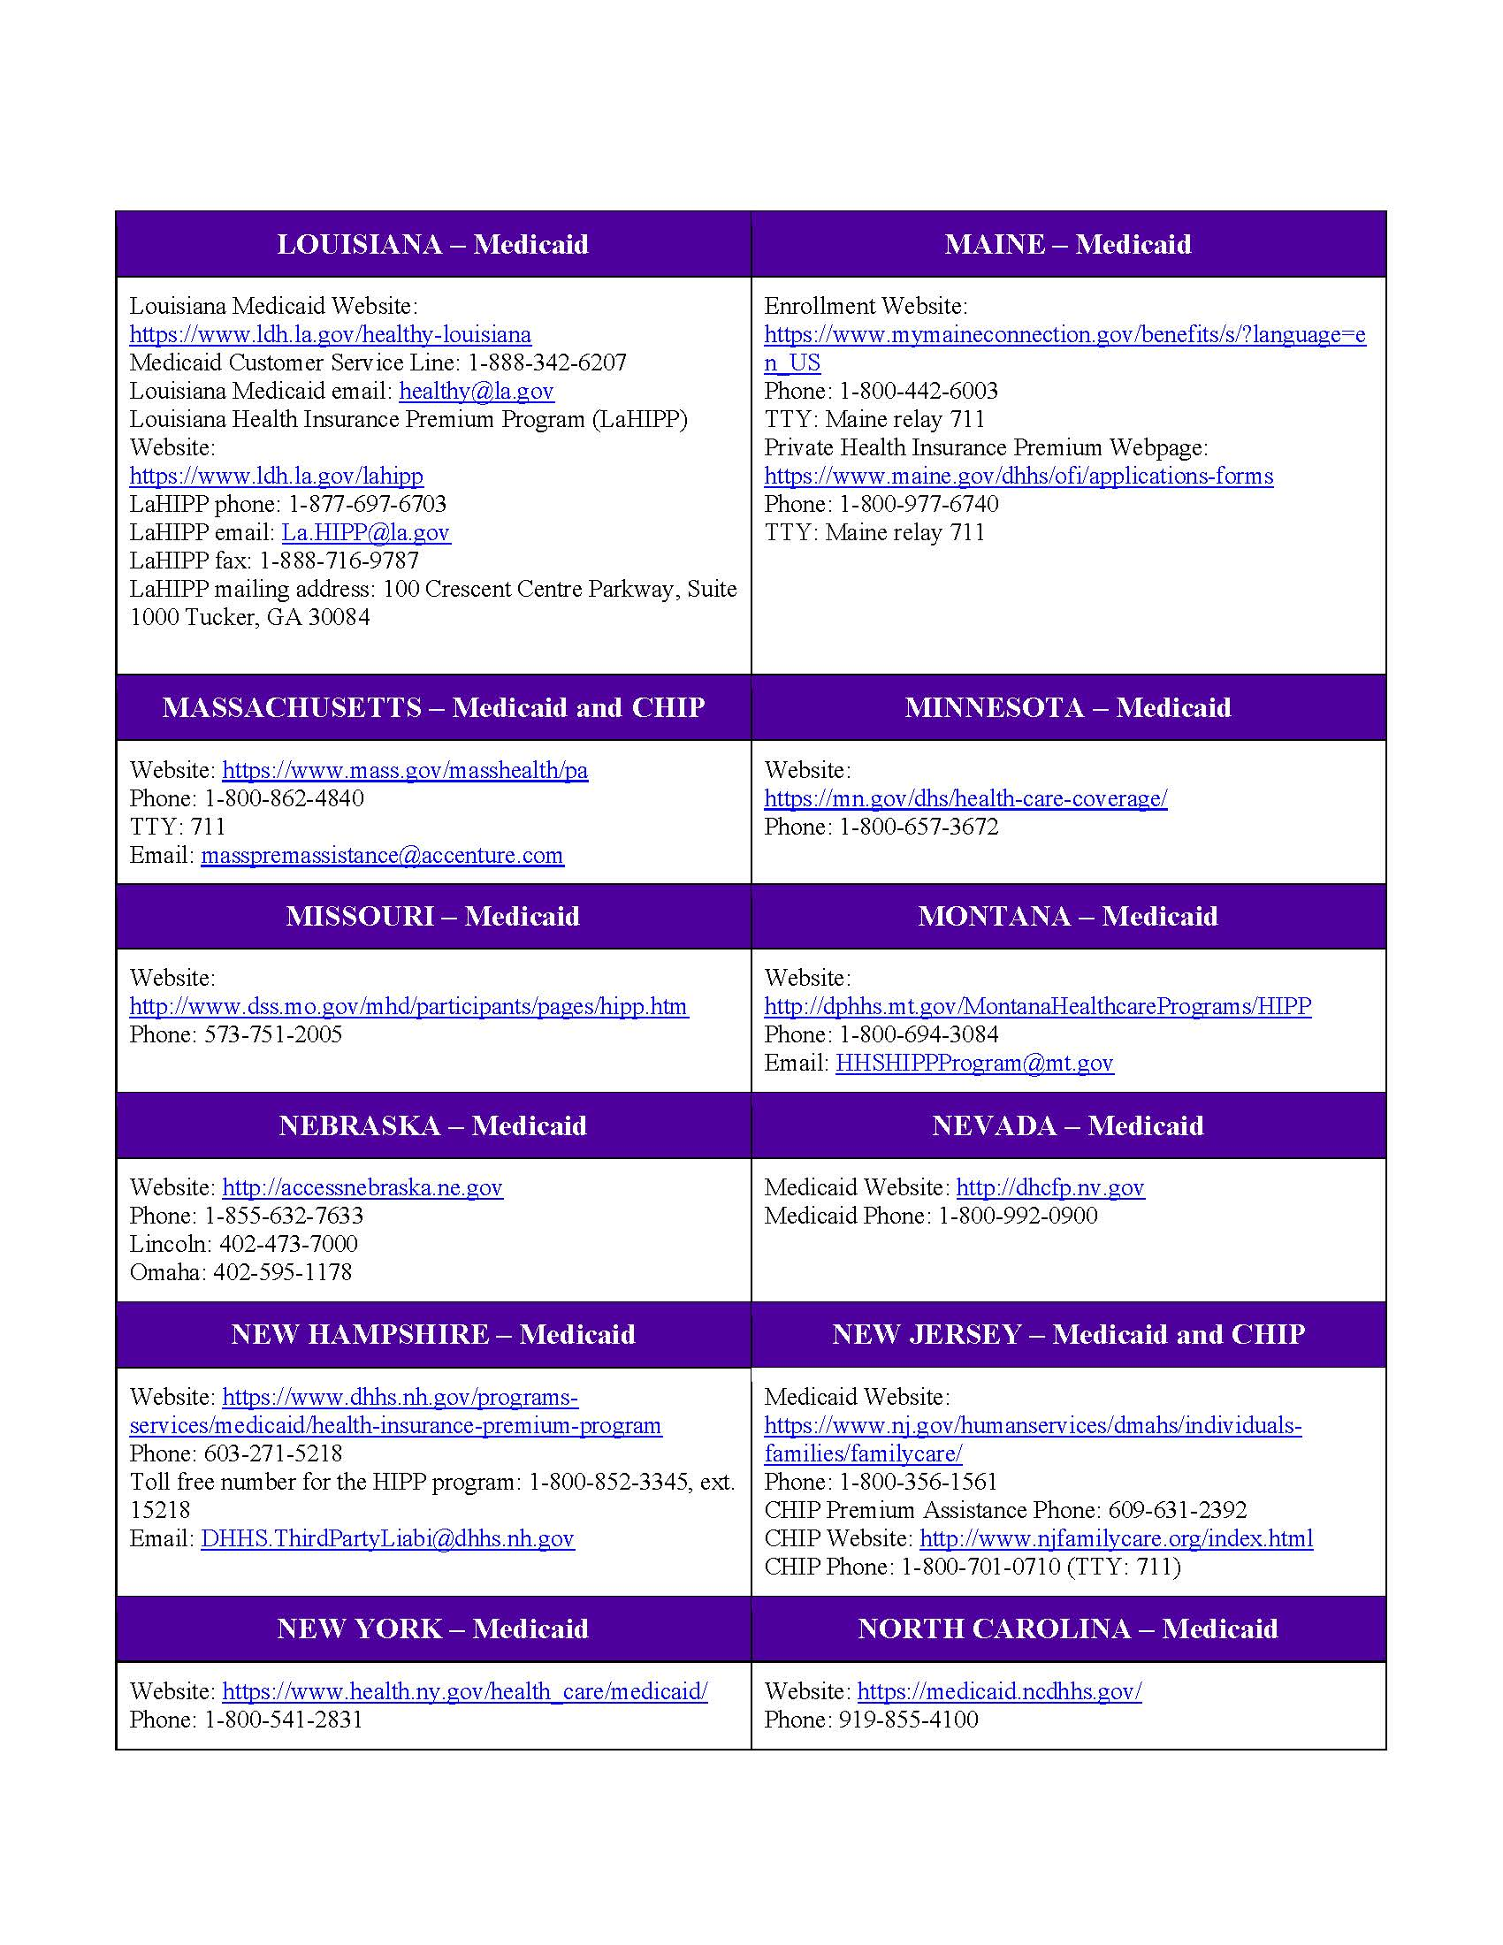
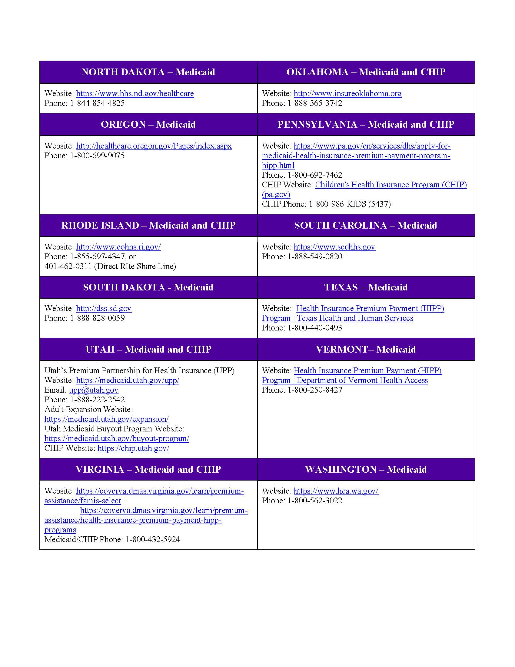
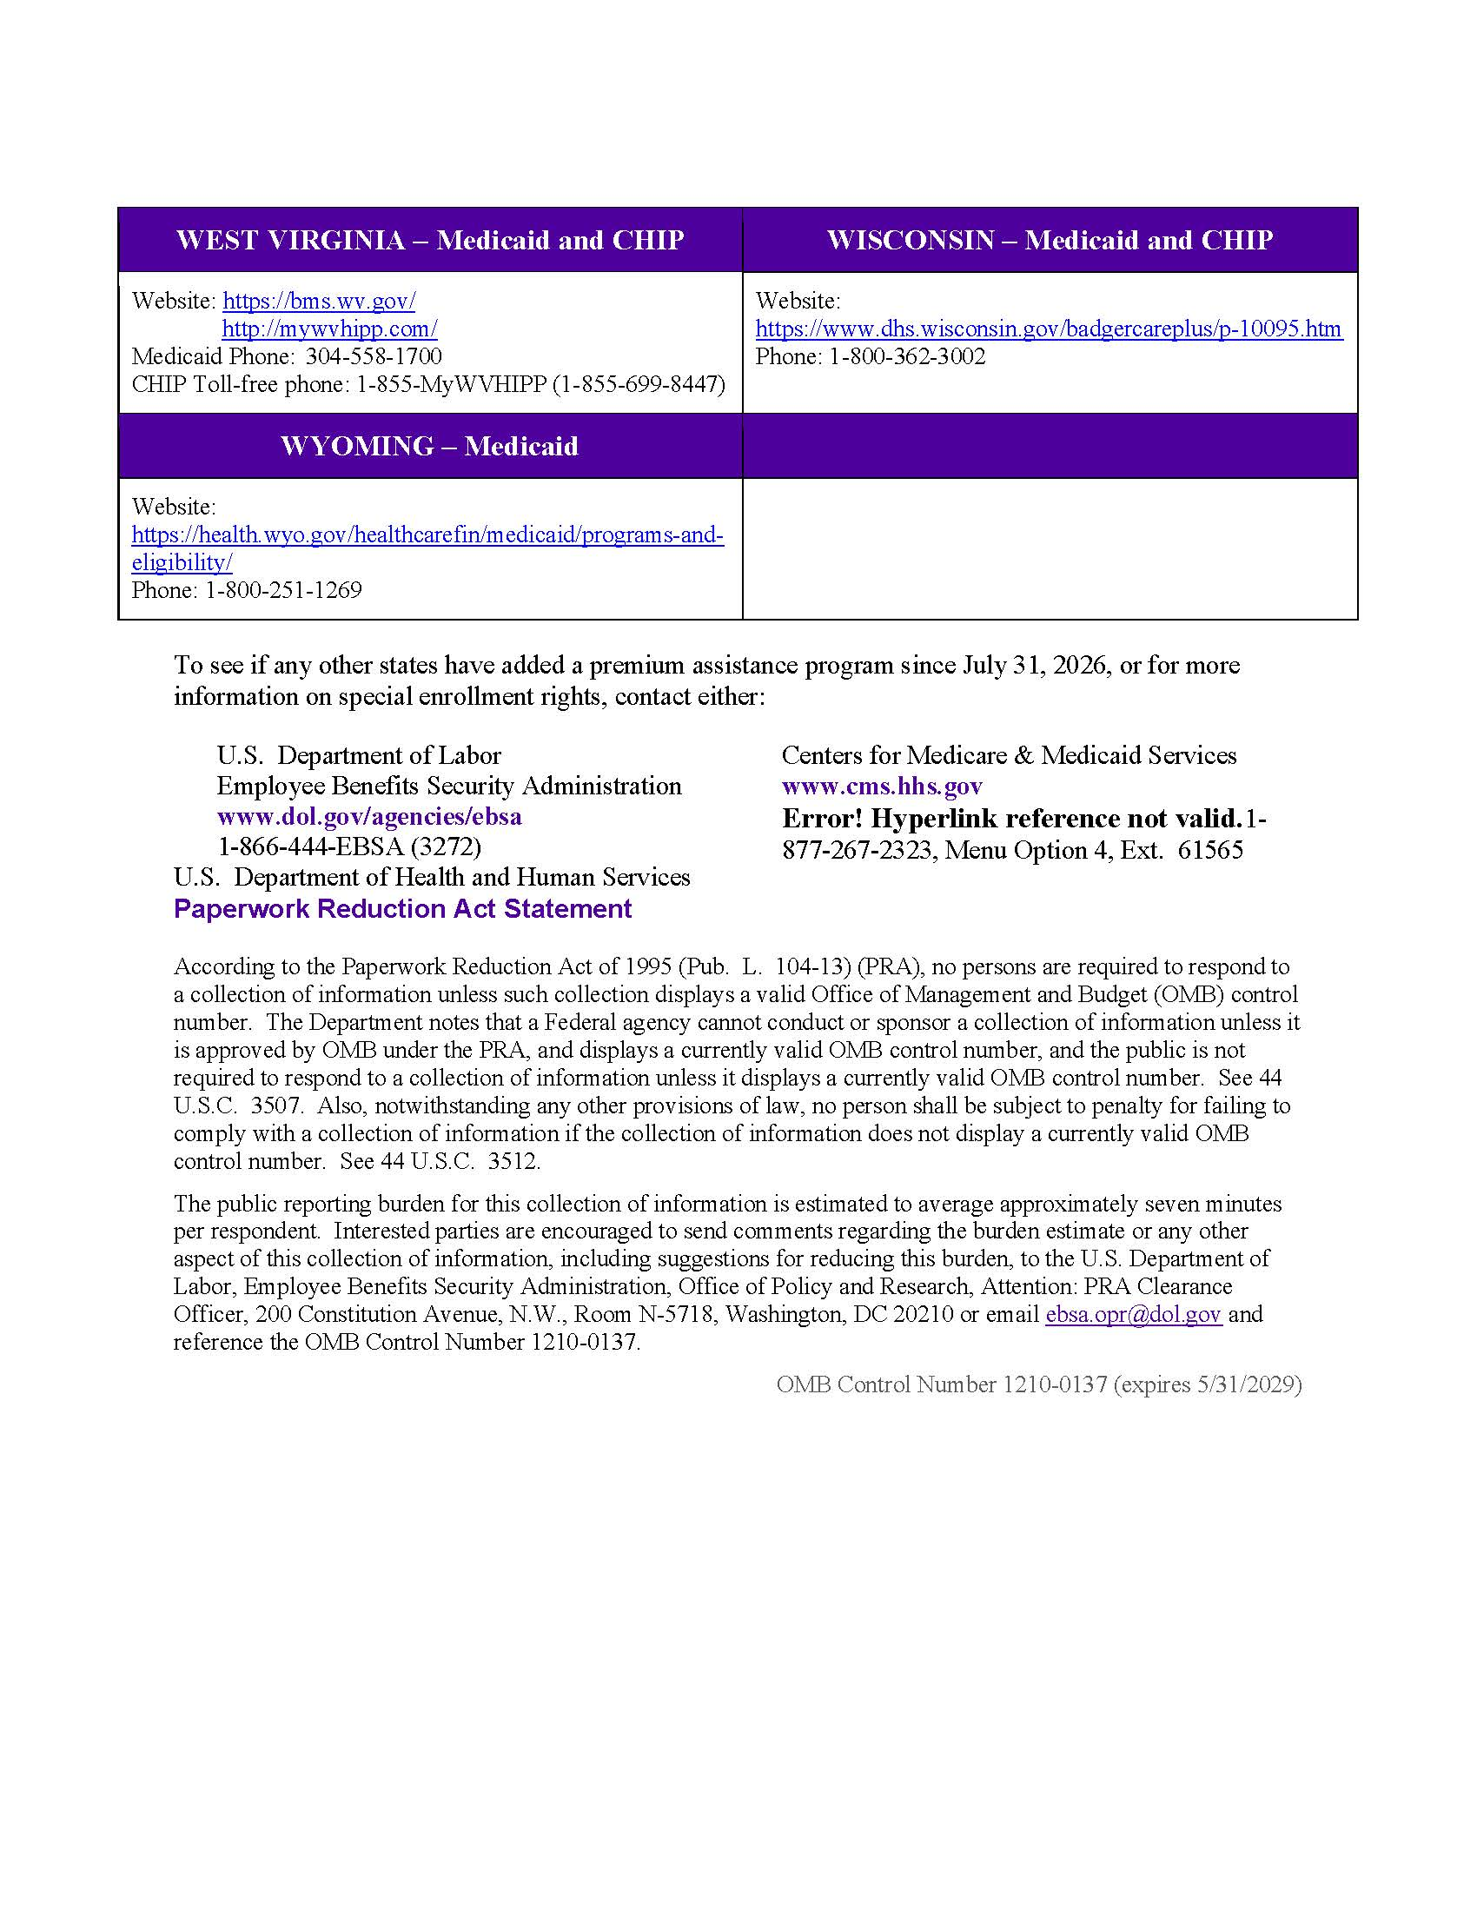

An employer-sponsored health plan meets the 'minimum value standard' if the plan’s share of the total allowed benefit costs covered by the plan is no less than 60 percent of such costs.

